WORK AND OFFICE VOCABULARY
September, 19th, 2020 Ph Update: April 2023 Nguyen V8
>Responsibilities
- What do you do for a living? To earn a living? What does your job consist in? What is your occupation?
- I’m responsible for updating the company website / I’m in charge of interviewing candidates for jobs.
- My job involves giving tours of the museum. /Within the frame of my job, I speak Japanese
- My job consists in designing new models
- Decomposition: My Department consists of three teams, one specialized in accountancy, the other one in finance, the third one in strategy.

>My company & Firm
- CDD/CDI: I work at (a company) with permanent contract (=unlimited-term contract) / temporary contract (=fixed-term contract)
- I work for (a company / a person)
- I work in (a place, city, country, department, or general area/industry)
- I work with (people / things)

>Unemployed
- I’m unemployed = I’m out of work = I’m between jobs at the moment.
- I’m looking for (a position/ opportunities). I have to take/sit job interviews to get a job.
- I’m on the dole (receiving money because of unemployment situation)

>If you’re good at your job, you might get a pay raise (or a raise) – an increase in your salary (by 10%/$1000)- perks (a car at your disposal, …)

>To resign
- I’m going to quit my job= I’m going to leave my job.
- I go on maternity leave/ I go on sick leave
- I retired in 2013, now in 2018, I am retired, I am a retiree
- Délai de préavis: He has to work for a two-month notice period in his former company
- Période d’essai: He’s about to pass his 6-month probation period/ trial period and then turn afterwards to be a permanent employee

>To be fired/ To be made redundant/ to be dismissed/ to be laid off/ to be sacked

>To turn down an offer (not to accept the job)

> Time:
- we typically use the expression go to work for arriving at work, and get off work for leaving work. For example, I go to work at 8:30, and I get off work at 5PM
- You can work full-time (usually about 40 hours per week) or part-time (usually 15-25 hours per week). A small number of companies offer flex-time, meaning the employee can set his/her own schedule.
- In some jobs, you work shifts meaning the hours are not the same every day; instead, you work a specific block of hours that the manager schedules. If you work overtime, it means you work extra hours in addition to your normal schedule.

>Status
- Apprentice – a person who learns a job or skill by working for a fixed period of time for someone who is very good at that job or skill.
- Trainee – a person who is being trained for a job. He does training or an internship.
- When you’re hired (=recruited/enrolled), you become an employee of the company. The company becomes your employer. The other employees in the company are your colleagues, teammates or coworkers. The person above you who is responsible for your work is your boss, manager or supervisor.
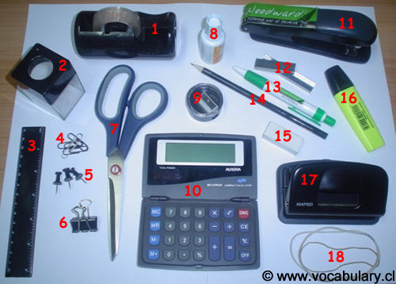
>Office tools
1-Tape (dispenser)  2-Paper clip holder  3-Ruler  4-Paper clips  5-Pushpins  6- Bulldog clip | 7-Scissors  8-Correction Fluid (white-out)  9-Pencil sharpener  10-Calculator  11-Stapler  12-Staples | 13-Pen  14-Pencil  15-Eraser (= rubber)  16-Highlighter  17-Hole-punch  18-Rubber bands (elastic bands)

>Engagement
- I work ON the study
- I collaborated (WITH a German partner) ON the experiments
- I participate IN the project / I am engaged IN the new projects
- I invest IN the sustainable energy sector
- An involvement IN the emerging sector
- You contributed TO the success of your company/ Thanks for your contribution TO the reliability of the system
- A commitment TO help unprivileged people/ A commitment TO the battle against diseases
- I subscribe TO the upcoming session (to with event or service)/ I subscribe for new Companies shares, for alternative ideas

